Project Title

Comprehensive Analysis and Dietary strategies with Tableau : A College Food Choices Case Study

Team Id : SWUID2026226489
SWUID2026226490SWUID2026226275
Team Size: 3

Team Member : Ram Sai Vanapalli

Team Member : Naga Pushpa Latha Ravula
Team Member : Sudheeksha Sangana

INTRODUCTION
  - Project Overview
"The Comprehensive Analysis and Dietary Strategies with Tableau: A College Food Choices Case Study is an interactive, data-driven web application designed to analyze the dietary habits and health awareness of college students. In the academic environment, food choices significantly impact student well-being, yet students often lack accessible information regarding nutritional values and consumption trends. Traditional methods of food tracking are manual, time-consuming, and fail to provide actionable insights. This project simplifies and automates the analysis process by leveraging Tableau’s visualization capabilities integrated with a Flask-based web interface. The system collects and processes student dietary data, allowing users to explore food consumption patterns, health correlations, and nutritional trends through dynamic, interactive dashboards. By combining data analytics with web technology, this project demonstrates how visual intelligence can be applied to foster better nutritional awareness and promote healthier lifestyle choices among students.".

  - Purpose
"The primary purpose of the Comprehensive Analysis and Dietary Strategies with Tableau project is to bridge the gap between complex dietary data and student health awareness by automating the visualization process. Instead of relying on manual surveys or static reports, this system empowers students and administrators to analyze food intake patterns, lifestyle choices, and health outcomes in real-time. This approach minimizes human error, reduces data processing time, and provides clear, data-driven insights that are easy to interpret.
Another core objective is to demonstrate the practical application of Business Intelligence (BI) tools in the education and wellness sector. The system provides an interactive platform where students can visualize their eating habits and understand the correlation between food choices and daily physical activity. Additionally, this project enhances technical proficiency in data cleaning, Flask web framework integration, and Tableau dashboard design. The platform is designed to be scalable, offering a foundation for future enhancements such as AI-driven personalized diet recommendations and integration with broader institutional wellness programs, making it a sustainable solution for fostering a healthier campus environment."
.

Ideation Phase
Brainstorm & Idea Prioritization Template

Date | 30 Jun 2026
Team ID | SWUID2026226489  SWUID2026226490  SWUID2026226275
Project Name | Comprehensive Analysis and Dietary Strategies with Tableau: A College Food Choices Case Study
Maximum Marks | 4 Marks

Brainstorm & Idea Prioritization Template:
Brainstorming provides a free and open environment that encourages everyone within a team to participate in the creative thinking process that leads to problem solving. Prioritizing volume over value, out-of-the-box ideas are welcome and built upon, and all participants are encouraged to collaborate, helping each other develop a rich amount of creative solutions.
Use this template in your own brainstorming sessions so your team can unleash their imagination and start shaping concepts even if you're not sitting in the same room.
Reference: https://www.mural.co/templates/brainstorm-and-idea-prioritization
Step-1: Team Gathering, Collaboration and Select the Problem Statement


Step-2: Brainstorm, Idea Listing and Grouping
Step-2: Brainstorm, Idea Listing and Grouping


Step-3: Idea Prioritization



Ideation Phase
Define the Problem Statements

Date | 30 Jun 2026
Team ID | SWUID2026226489  SWUID2026226490  SWUID2026226275
Project Name | Comprehensive Analysis and Dietary Strategies with Tableau: A College Food Choices Case Study
Maximum Marks | 2 Marks

Customer Problem Statement Template:
Create a problem statement to understand your customer's point of view. The Customer Problem Statement template helps you focus on what matters to create experiences people will love.
A well-articulated customer problem statement allows you and your team to find the ideal solution for the challenges your customers face. Throughout the process, you’ll also be able to empathize with your customers, which helps you better understand how they perceive your product or service.

Reference: https://miro.com/templates/customer-problem-statement/
Example:


Problem Statement (PS) | I am (Customer) | I’m trying to | But | Because | Which makes me feel
PS-1 | A college student | Choose healthy food options in canteen | There is a lack of nutritional information | The current menu doesn't show calorie or health data | Confused about my diet
PS-2 | Track my daily food intake habits | Track my daily food intake habits | It's hard to visualize my eating patterns | Manual tracking is time consuming and difficult | Frustrated with my lifestyle

Ideation Phase
Empathize & Discover

Date | 30 Jun 2026
Team ID | SWUID2026226489  SWUID2026226490  SWUID2026226275
Project Name | Comprehensive Analysis and Dietary Strategies with Tableau: A College Food Choices Case Study
Maximum Marks | 4 Marks

Empathy Map Canvas:
An empathy map is a simple, easy-to-digest visual that captures knowledge about a user’s behaviours and attitudes.

It is a useful tool to helps teams better understand their users.
Creating an effective solution requires understanding the true problem and the person who is experiencing it. The exercise of creating the map helps participants consider things from the user’s perspective along with his or her goals and challenges.
Example:


Reference: https://www.mural.co/templates/empathy-map-canvas

Example: Food Ordering & Delivery Application












F A I R P L A N E

Guided city tours

Based on ten customer interviews and observations from the Fairplane Guided City Tours team

Claudia Larmon

Menaka Mahajan

Jerome Phillips

Alejandro Flores

Emma Sato

Entice

SCENARIO

Browsing, booking, attending, and rating a local city tour
How does someone initially become aware of this process?

Enter
What do people experience as they begin the process?

Engage
In the core moments in the process, what happens?

Exit
What do people typically experience
as the process finishes?

Extend
What happens after the experience is over?

Steps
Personalized tour suggestions after new travel booking

Personalized tour offers

Personalized recommendations

Tour appears in the user profile
Writing & submitting review

Prompt for review

Leave the guide & group

Experience the tour

Meet the guide & group

Arrive at tour location

Email reminder

Email confirmation

Confirm payment & book tour

Complete payment information

Start purchase of a tour

View detail on a single tour

Browse available tours
Choose a city, dates, and number of people

Visit website or app

Booking other travel
What does the person (or group) typically experience?
Most customers discover city tours as they are booking other Fairplane travel
A customer navigates to the city tours section of our website or app
The customer types a city, dates, and the number of people who will attend the tour to see what tours are available
The customer sees available tours for their dates, city, and number of people

After seeing a tour that interests them, the customer clicks or taps to view more. They see information about what and where the tour will cover, plus its price, time of day, and tour guide.
After deciding to go on this tour, they click the Purchase button
They fill out their contact and credit card information, then continue
They see a summary of what they are about to purchase, then they confirm and the tour is booked!
An email immediately sends to confirm their tour and provide details about where and when to meet their guide
One day before the tour begins, a reminder email is sent to all tour participants. The email emphasizes where and when to meet, and what to bring (if applicable).
Using their own means of transportation, the customer makes their way to the tour location at the scheduled time.
Tour participants meet the guide and other people who have joined the same tour
The guide brings the group around the area, explaining things as they go. Typically this lasts about 3 hours.
The guide wraps up the tour and everyone heads their separate ways
One hour after the tour finishes, an email and in-app notification prompt the tour participant for a review
The tour participant writes a review and gives the tour a star-rating out of 5.

The completed tour appears on the "past experiences" area of a customer's profile with a few details on where the group went
Participation in the tour informs our backend recommendation systems, which the customer may experience via better personalization
The customer receives an email 14 days after their tour with personalized recommendations for other tours

When a past tour participant books new travel with us, we show them personalized tour recommendations in their arrival city.

Interactions
Post-purchase screens website, iOS app, or Android app
Customer's email (software like Outlook or website like Gmail)
Recommendations span across website, iOS app, or Android app
Completed experiences section of the profile on the website, iOS app, or Android app
“Leave a review” modal window within the profile on the website, iOS app, or Android app
Customer's email (software like Outlook or website like Gmail)
Direct interactions with the guide, and potentially other group members
Direct interactions with the guide, and potentially other group members
Direct interactions with the guide, and potentially other group members
Tour locations tend to start in a specific public space (e.g. the steps of a statue in a town square)
Customer's email (software like Outlook or website like Gmail)
Customer's email (software like Outlook or website like Gmail)
Payment overlay within the website, iOS app,
or Android app
Payment overlay within the website, iOS app,
or Android app
City tours section of the website, iOS app, or Android app
City tours section of the website, iOS app, or Android app
City tours section of the website, iOS app, or Android app
City tours section of the website, iOS app, or Android app
City tours section of the website, iOS app, or Android app
Travel booking section of the website, iOS app, or Android app
What interactions do they have at each step along the way?
If other users interact with this person, they will see these completed tours also
To some degree, this is communicating indirectly with the tour guide, who will see their review
Often takes place at the same place where the group met the guide, but not always
Some tours include interactions with shopkeepers or restaurant staff (e.g. on a food-oriented tour)
The customer looks for the group or guide, often from a distance as they walk closer
The tour guide makes first appearance at this point, although the customer doesn't interact with them yet.
People: Who do they see or talk to?
Places: Where are they?
Things: What digital touchpoints or physical objects would they use?
Depending on the tour participant and guide, tipping/cash may be involved
Most common objects people interact with on tours are bikes, Segways, food, and beverages.

Goals & motivations

Help me see ways to enhance my new trip

Help me see what I could be doing next

Help me see what I've done before
Help me spread the word about a great tour or provide watch-outs and feedback for one that was not so good
Help me leave the tour with good feelings and no awkwardness
Help me make the most of my trip to this new place
Help me feel good about my decision to go on this tour and to feel welcome
Help me feel confident about where to go and which one of these people is my guide
Help me make sure I don't forget about my tour so that I don't waste money or get disappointed
Help me feel confident that my purchase is finalized and tell me what to do next
Help me feel confident that my purchase is finalized and tell me what to do next
Help me get through this payment part without too much hassle

Help me commit to going on this tour
Help me understand what this tour is all about

Help me see what they have to offer
Help me avoid seeing tours for the wrong dates, locations, or numbers of people
Help me have more fun or learn new things on my trip
Help me get this flight or hotel booked
At each step, what is a person’s primary goal or motivation? (“Help me...” or “Help me avoid...”)

Positive moments
What steps does a typical person find enjoyable, productive, fun, motivating, delightful, or exciting?

It's fun to look at options and imagine doing each tour, like shopping for experiences

It's reassuring to red reviews written by past travelers
We think people like these recommendations because they have an extremely high engagement rate
People like looking back on their past trips

Excitement about the purchase
("Here we go!")
Tour photos, videos, and explanations are exciting to see

Current payment flow is very bare-bones and simple

We've heard from several people that the reminder emails were essential, especially if they booked way in advance

Our guides tend to be so good that people are reassured when they meet their guide

People love the tour itself, we have a 98% satisfaction rating

People generally leave tours feeling refreshed and inspired

Negative moments
What steps does a typical person find frustrating, confusing, angering, costly, or time-consuming?

People sometimes forget to put in their dates or number of people, which leads them to discover tours they can't actually attend

Several people expressed "information overload" as they browse

People express a bit of fear of commitment at this step

Trepidation about the purchase
("I hope this will be worth it!")

People expressed awkwardness about finding their guide in a public place

Sometimes people are matched up with tour participants that they don't really like

People are unclear whether a tip is necessary, especially for non-Americans on an American tour

People feel peer pressure to tip a guide when someone else on the tour tips, leaving them feeling weird and bad if they don't

Customers report feeling review fatigue

We have very low review rates (15% of people review experiences and tours)

People describe leaving a review as an arduous process

Areas of opportunity
How might we make each step better? What ideas do we have? What have others suggested?

If you don't follow this path immediately after your booking, could we send a follow-up?

Could we automatically carry over the city from your booking? (e.g. via a cookie)

Make it easier to compare and shop for experiences without having to click on them

Provide a simpler summary to avoid information overload

Show highlights or common phrases from reviews, or Uber style "great guide" badges?

How might we make our guides easily identifiable (via a distinctive hat or shirt color, for example)?

How might we make it clear that tipping is appreciated but not necessary?

How might we equip people to tip after the tour? (e.g. via Venmo or equivalent app)

Could we A/B test different language to see what changes response rates?

How might we progressively disclose the full review so that each step feels more simple?

How might we help people celebrate and remember things they've done in the past?

How might we extend the personal connection to the guide long after the tour is over?

ow might we totally eliminate this awkward moment?

Project Design Phase-II
Data Flow Diagram & User Stories

Date | 30 Jun 2026
Team ID | SWUID2026226489  SWUID2026226490  SWUID2026226275
Project Name | Comprehensive Analysis and Dietary  Strategies with Tableau: A College Food  Choices Case Study
Maximum Marks | 4 Marks

Data Flow Diagrams:
A Data Flow Diagram (DFD) is a traditional visual representation of the information flows within a system. A neat and clear DFD can depict the right amount of the system requirement graphically. It shows how data enters and leaves the system, what changes the information, and where data is stored.

Example: (Simplified)

User Stories
Use the below template to list all the user stories for the product.
User Type | Functional Requirement (Epic) | User Story Number | User Story / Task | Acceptance criteria | Priority | Release
Customer (Mobile user) | Registration | USN-1 | As a user, I can register for the application by entering my email, password, and confirming my password. | I can access my account / dashboard | High | Sprint-1
Customer (Mobile user) | Registration | USN-2 | As a user, I will receive confirmation email once I have registered for the application | I can receive confirmation email & click confirm | High | Sprint-1
Customer (Mobile user) | Registration | USN-3 | As a user, I can register for the application through Facebook | I can register & access the dashboard with Facebook Login | Low | Sprint-2
Customer (Mobile user) | Registration | USN-4 | As a user, I can register for the application through Gmail | Dashboard is accessible via Gmail login | Medium | Sprint-1
Customer (Mobile user) | Login | USN-5 | As a user, I can log into the application by entering email & password | User is redirected to the main dashboard | High | Sprint-1
Customer (Web user) | Dashboard | USN-6 | As a student, I can view dietary habit insights on the dashboard. | Dashboard displays interactive charts successfully. | High | Sprint-2
Customer (Web user) | Data Analysis | USN-7 | As a student, I can filter food data by category. | Data updates dynamically based on user filters. | High | Sprint-2
Administrator | Application Support | USN-8 | As a support executive, I can resolve student queries regarding diet logs. | Support requests are resolved efficiently. | Medium | Sprint-3
Customer Care Executive | User Management | USN-9 | As an administrator, I can manage student accounts and access. | User records are updated successfully. | High | Sprint-3
Administrator | System Monitoring | USN-10 | As an administrator, I can monitor dashboard performance | Performance reports are available. | Medium | Sprint-3

Project Design Phase-II
Solution Requirements (Functional & Non-functional)

Date | 30 Jun 2026
Team ID | SWUID2026226489  SWUID2026226490  SWUID2026226275
Project Name | Comprehensive Analysis and Dietary Strategies  with Tableau: A College Food Choices Case  Study
Maximum Marks | 4 Marks

Functional Requirements:
Following are the functional requirements of the proposed solution.
FR No. | Functional Requirement (Epic) | Sub Requirement (Story / Sub-Task)
FR-1 | User Registration | Registration through Form  Registration through Gmail  Registration through LinkedIN
FR-2 | User Confirmation | Confirmation via Email  Confirmation via OTP
FR-3 | Food Choice Selection | Select food categories, view nutritional data
FR-4 | Data Visualization | Display interactive Tableau charts , filter analysis
FR-5 | Report Generation | Generate and download health analysis reports as PD
FR-6 | Personalized feedback | View dietary habit analysis and health-based recommendations

Non-functional Requirements:
Following are the non-functional requirements of the proposed solution.
FR No. | Non-Functional Requirement | Description
NFR-1 | Usability | Simple and user-friendly interface for students
NFR-2 | Security | Student data and dietary logs must be securely stored
NFR-3 | Reliability | Accurate and consistent food data analysis results
NFR-4 | Performance | Dashboard visualization should load within 3 seconds
NFR-5 | Availability | Application should be accessible 24*7 for students
NFR-6 | Scalability | System should support multiple concurrent student users

Project Design Phase-II
Technology Stack (Architecture & Stack)

Date | 30 Jun 2026
Team ID | SWUID2026226489  SWUID2026226490  SWUID2026226275
Project Name | Comprehensive Analysis and Dietary Strategies with Tableau: A College Food Choices Case Study
Maximum Marks | 4 Marks

Technical Architecture:
The Deliverable shall include the architectural diagram as below and the information as per the table1 & table 2
Example: Order processing during pandemics for offline mode
Reference: https://developer.ibm.com/patterns/ai-powered-backend-system-for-order-processing-during-pandemics/
Guidelines:
Include all the processes (As an application logic / Technology Block)
Provide infrastructural demarcation (Local / Cloud)
Indicate external interfaces (third party API’s etc.)
Indicate Data Storage components / services
Indicate interface to machine learning models (if applicable)



Table-1 : Components & Technologies:

S.No | Component | Description | Technology
 | User Interface | How user interacts with application e.g.  Web UI, Mobile App, Chatbot etc. | HTML, CSS, JavaScript / Angular Js / React Js etc.
 | Application Logic-1 | Logic for a process in the application | Java / Python
 | Application Logic-2 | Logic for a process in the application | IBM Watson STT service
 | Application Logic-3 | Logic for a process in the application | IBM Watson Assistant
 | Database | Data Type, Configurations etc. | MySQL, NoSQL, etc.
 | Cloud Database | Database Service on Cloud | IBM DB2, IBM Cloudant etc.
 | File Storage | File storage requirements | IBM Block Storage or Other Storage Service or Local Filesystem

 | External API-1 | Purpose of External API used in the application | IBM Weather API, etc.
 | External API-2 | Purpose of External API used in the application | Aadhar API, etc.
 | Machine Learning Model | Purpose of Machine Learning Model | Object Recognition Model, etc.
 | Infrastructure (Server / Cloud) | Application Deployment on Local System / Cloud  Local Server Configuration:  Cloud Server Configuration : | Local, Cloud Foundry, Kubernetes, etc.

Table-2: Application Characteristics:

S.No | Characteristics | Description | Technology
 | Open-Source Frameworks | List the open-source frameworks used | Technology of Opensource framework
 | Security Implementations | List all the security / access controls implemented, use of firewalls etc. | e.g. SHA-256, Encryptions, IAM Controls, OWASP etc.
 | Scalable Architecture | Justify the scalability of architecture (3 – tier, Micro-services) | Technology used
 | Availability | Justify the availability of application (e.g. use of load balancers, distributed servers etc.) | Technology used
 | Performance | Design consideration for the performance of the application (number of requests per sec, use of Cache, use of CDN’s) etc. | Technology used

References:
https://c4model.com/
https://developer.ibm.com/patterns/online-order-processing-system-during-pandemic/
https://www.ibm.com/cloud/architecture
https://aws.amazon.com/architecture

Project Design Phase
Problem – Solution Fit Template

Date | 30 June 2026
Team ID | SWUID2026226489  SWUID2026226490  SWUID2026226275
Project Name | Comprehensive Analysis and Dietary Strategies with Tableau: A College Food Choices Case Study
Maximum Marks | 2 Marks

Problem – Solution Fit Template:

The Problem-Solution Fit simply means that you have found a problem with your customer and that the solution you have realized for it actually solves the customer’s problem. It helps entrepreneurs, marketers and corporate innovators identify behavioral patterns and recognize what would work and why
Purpose:
- Solve complex problems in a way that fits the state of your customers.
- faster and increase your solution adoption by tapping into existing mediums and channels of behavior.
- Sharpen your communication and marketing strategy with the right triggers and messaging.
- Increase touch-points with your company by finding the right problem-behavior fit and building trust by solving frequent annoyances, or urgent or costly problems.
- Understand the existing situation in order to improve it for your target group.


References:
- https://www.ideahackers.network/problem-solution-fit-canvas/
- https://medium.com/@epicantus/problem-solution-fit-canvas-aa3dd59cb4fe

Project Design Phase
Proposed Solution Template

Date | 30 Jun 2026
Team ID | SWUID2026226489  SWUID2026226490  SWUID2026226275
Project Name | Comprehensive Analysis and Dietary Strategies with Tableau: A College Food Choices Case Study
Maximum Marks | 2 Marks

Proposed Solution Template:
Project team shall fill the following information in the proposed solution template.
S.No. | Parameter | Description
 | Problem Statement (Problem to be solved) | College students often struggle with making informed nutritional choices due to the lack of accessible and understandable dietary data.
 | Idea / Solution description | Develop an interactive, web-based dashboard using Tableau and Flask to visualize student food consumption patterns and provide health-conscious insights.
 | Novelty / Uniqueness | Combines real-world college food consumption datasets with interactive BI tools to offer personalized nutritional awareness at an institutional level.
 | Social Impact / Customer Satisfaction | Promotes healthier eating habits among students, raising awareness about nutritional balance and long-term health outcomes.
 | Business Model (Revenue Model) | Can be implemented as a health-tech service for college cafeterias or wellness programs through institutional subscriptions.
 | Scalability of the Solution | The dashboard architecture allows for the integration of larger datasets from multiple campuses and the addition of predictive health analytics.

Project Design Phase
Solution Architecture

Date | 30 Jun 2026
Team ID | SWUID2026226489  SWUID2026226490  SWUID2026226275
Project Name | Comprehensive Analysis and Dietary Strategies with Tableau: A College Food Choices Case Study
Maximum Marks | 4 Marks

Solution Architecture:
Solution architecture is a complex process – with many sub-processes – that bridges the gap between business problems and technology solutions. Its goals are to:
- Find the best tech solution to solve existing business problems.
- Describe the structure, characteristics, behavior, and other aspects of the software to project stakeholders.
- Define features, development phases, and solution requirements.
- Provide specifications according to which the solution is defined, managed, and delivered.

Example - Solution Architecture Diagram:


Figure 1: Architecture and data flow of the voice patient diary sample application
Reference: https://aws.amazon.com/blogs/industries/voice-applications-in-clinical-research-powered-by-ai-on-aws-part-1-architecture-and-design-considerations/

Project Planning Phase
Project Planning Template (Product Backlog, Sprint Planning, Stories, Story points)

Date | 30 Jun 2026
Team ID | SWUID2026226489  SWUID2026226490  SWUID2026226275
Project Name | Comprehensive Analysis and Dietary Strategies with Tableau: A College Food Choices Case Study
Maximum Marks | 5 Marks

Product Backlog, Sprint Schedule, and Estimation (4 Marks)
Use the below template to create product backlog and sprint schedule
Sprint | Functional Requirement (Epic) | User Story Number | User Story / Task | Story Points | Priority | Team Members
Sprint-1 | Registration | USN-1 | As a user, I can register for the application by entering my email, password, and confirming my password. | 2 | High | Team
Sprint-1 | Dashboard | USN-2 | As a user, I will receive confirmation email once I have registered for the application | 1 | High | Team
Sprint-2 | Application Support | USN-3 | As a user, I can register for the application through Facebook | 2 | Low | Team
Sprint-1 | System Monitoring | USN-4 | As a user, I can register for the application through Gmail | 2 | Medium | Team
Sprint-1 | Login | USN-5 | As a user, I can log into the application by entering email & password | 1 | High | Team
 | Dashboard

Project Tracker, Velocity & Burndown Chart: (4 Marks)
Sprint | Total Story Points | Duration | Sprint Start Date | Sprint End Date (Planned) | Story Points Completed (as on Planned End Date) | Sprint Release Date (Actual)
Sprint-1 | 20 | 3 Days | 24 Jun 2026 | 26 Jun 2026 | 20 | 26 Jun 2026
Sprint-2 | 20 | 2 Days | 27 Jun 2026 | 28 Jun 2026 | 20 | 28 Jun 2026
Sprint-3 | 20 | 5 Days | 29 Jun 2026 | 30 Jun 2026 | 20 | 30 Jun 2026
Sprint-4 | 20 | 6 Days | 01 Jul 2026 | 03 Jul 2026 | 20 | 03 Jul 2026

Velocity:
Imagine we have a 10-day sprint duration, and the velocity of the team is 20 (points per sprint). Let’s calculate the team’s average velocity (AV) per iteration unit (story points per day)


Burndown Chart:

A burn down chart is a graphical representation of work left to do versus time. It is often used in agile software development methodologies such as Scrum. However, burn down charts can be applied to any project containing measurable progress over time.

https://www.visual-paradigm.com/scrum/scrum-burndown-chart/ https://www.atlassian.com/agile/tutorials/burndown-charts

Reference:
https://www.atlassian.com/agile/project-management https://www.atlassian.com/agile/tutorials/how-to-do-scrum-with-jira-software https://www.atlassian.com/agile/tutorials/epics https://www.atlassian.com/agile/tutorials/sprints https://www.atlassian.com/agile/project-management/estimation https://www.atlassian.com/agile/tutorials/burndown-charts

Functional & Performance Testing
Project Performance Test

Date | 30 June 2026
Team ID | SWUID2026226489  SWUID2026226490  SWUID2026226275
Project Name | Comprehensive Analysis and Dietary  Strategies with Tableau: A College Food Choices Case Study
Maximum Marks | 4 Marks

Model Performance Testing:
Project team shall fill the following information in model performance testing template.

S.No. | Parameter | Screenshot / Values
1. | Data Rendered | Screenshot of Tableau Public connected to CSV source
2. | Data Preprocessing | Value: Cleaned and structured dietary dataset with 0 null values.
3. | Utilization of Filters | Screenshot of dynamic category/demographic filters applied.
4. | Calculation fields Used | Value: Applied 'Nutritional Index' and 'Calorie Count' calculated fields.
5. | Dashboard design | No of Visualizations / Graphs – 6 interactive charts
6 | Story Design | No of Visualizations / Graphs -2 interactive story points

7.1 Output Screenshots

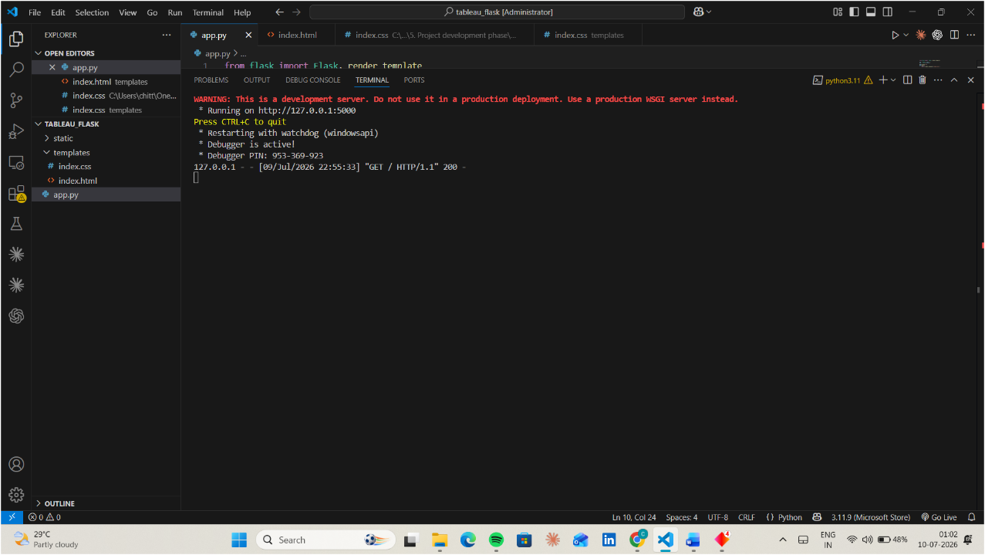
The Comprehensive Analysis and Dietary Strategies with Tableau project was successfully developed and tested using a Python-Flask web framework. The application integrates an interactive Tableau dashboard to visualize complex student dietary data. The system enables users to explore various parameters such as weight, exercise frequency, vitamin consumption, and comfort food preferences through dynamic, data-driven visual representations

Home Page
The home page of the Food Choice Analysis Dashboard provides an intuitive overview of the college food choices study. It introduces the primary purpose of the application, which is to analyze and visualize the dietary patterns and nutritional trends of college students.
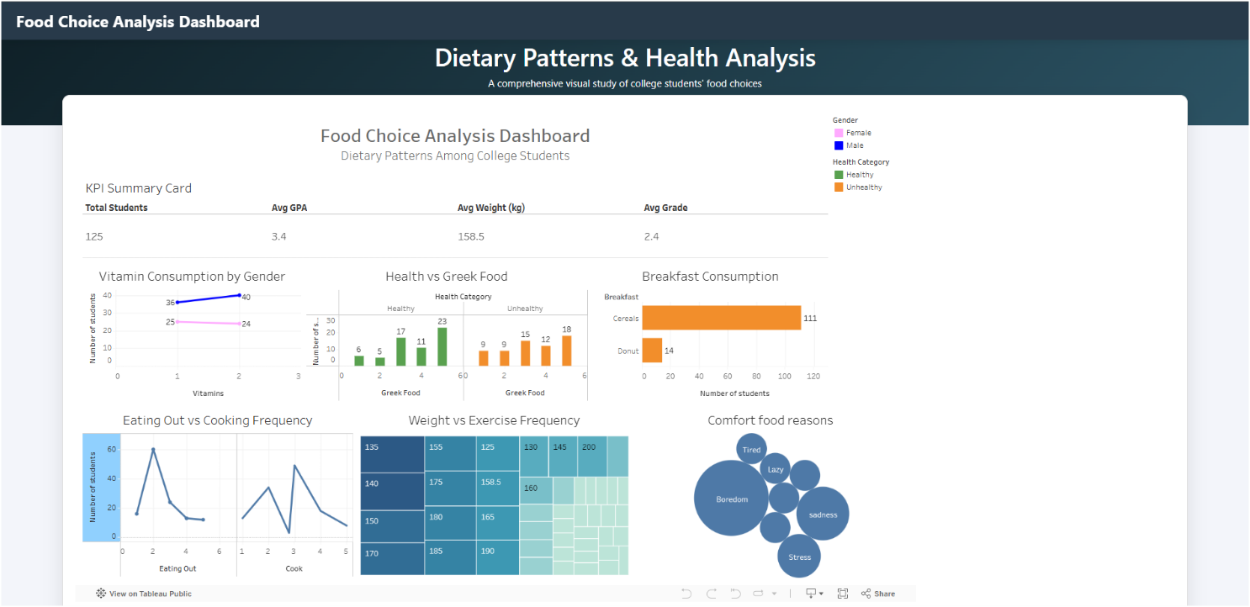

ADVANTAGES & DISADVANTAGES

Advantages

  - Data-Driven Insights: Provides fast and accurate analysis of student dietary patterns and health correlations.Reduces manual effort in the loan approval process.
  - Reduces Manual Effort: Automates the visualization process, eliminating the need for manual data surveys and static reportEasy-to-use and user-friendly web interface.
  - Improves Decision-Making: Helps students and administrators make informed choices regarding health and nutritional well-beingSupports real-time loan prediction.
  - Interactive Interface: Offers an easy-to-use and intuitive web interface for exploring complex health metrics.
  - Efficiency: Saves significant time in data processing and trend identification for researchers and students.
  - Real-Time Analytics: Supports real-time exploration of student food choices through dynamic dashboard filters.

Disadvantages

Data Quality Dependency: The accuracy and reliability of the dashboard depend

heavily on the quality and completeness of the student dietary dataset.

Maintenance: The dashboard may require updates or refinements when newer

survey data or broader nutritional metrics become available.

User Input Errors: Inaccurate data entry during surveys can lead to skewed
visualization results

Scope Limitation: The system provides analytical insights and cannot replace
Of personalized medical or professional dietary consultation.

CONCLUSION

The Comprehensive Analysis and Dietary Strategies with Tableau project was successfully developed and tested using data visualization and web integration techniques. The application effectively analyzes and presents college students' dietary habits, providing quick and reliable visual insights. By automating data exploration, the project reduces manual analysis effort, improves institutional understanding of student health trends, and demonstrates the practical application of BI tools in the education and wellness sector..

FUTURE SCOPE

• Integrate real-time survey data collection forms directly into the dashboard.
• Develop advanced predictive analytics to forecast nutritional health trends among students.
• Add personalized user profiles for students to track their individual dietary progress.
• Deploy the application on cloud platforms for global accessibility.
• Create a mobile-optimized version for convenient access on the go.
• Generate automated monthly health recommendation reports for campus wellness programs.

APPENDIX
Source Code
The complete source code of the A College Food Choices Case Study is available in the GitHub repository.

GitHub Repository
https://github.com/chittlusai/A-College-Food-Choices-Case-Study
Project Demo Link:
https://drive.google.com/file/d/1o_ggb-P_eWY95L3oGC6l7Yn7KGLUHIgv/view?usp=sharing

